Ancient Egyptian Newspaper

For the Chapter 2 Project, your group will be required to create an ancient Egyptian newspaper. You will only be responsible for creating the front page of a newspaper like the ones that hang on the walls of my classroom.

The newspapers need to be displayed on a poster board that is spaced out like a real newspaper.

To save time, I have attached to this project sheet a full click and paste hieroglyphic alphabet. All you should have to do is click on the letters and arrange them so they are in the proper spot for your project.

Each newspaper should have a title like “Ancient Egyptian Times” or something of that kind, a major headline, a main story that the headline is about and other side things like weather reports and other sections of the paper that will not actually be there. Remember, as always, the more creative that you are, the more extra points that you can get.

- An Ancient Egyptian Newspaper
- Title of Newspaper
- Major Headline
- Main Story
- Side things

The project is due September 19. 2018.

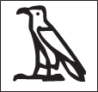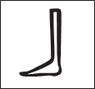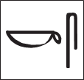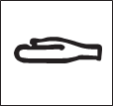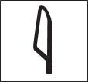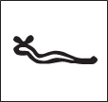
A B C D E F G
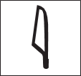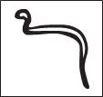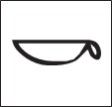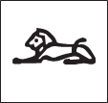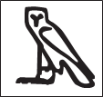
H I J K L M N
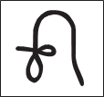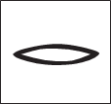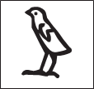
O P Q R S T U
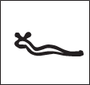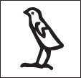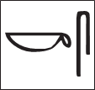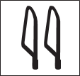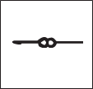
V W X Y Z

